**Impact of COVID-19 on Food Security – Visualization Dashboard**

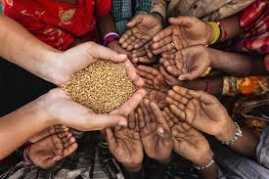

**Team Name: Neurotics**

**Report by:**

**Phalguni Shendye**

**Ashutosh Pandey**

**Anish Talwelkar**

Contents

Introduction: 3

Food Export Restrictions and Supply Chain Disruptions 4

Supply Chain 4

Why is Supply Chain Management important? 4

Supply Chain Management in Agriculture 4

Issues related to Supply Chain Management 5

Food Insecurity Experience Scale (FIES) 5

Analyzing the Supply-Demand Balance Of Commodities 7

Results - 8

Stocks to Use ratio over the years 8

Results – 11

Model to predict the supply-demand gap using the Stocks to Use Ratio 11

FIES Analysis Methodology: 11

Key concepts 11

Relative severity of questions 11

Standard labels for the eight questions 12

Preparing the data for analysis 12

FIES analysis methodology 14

Assumptions of the Rasch model 14

Expected response pattern 14

The analytical tools 14

How the tool works? 15

Assessing data quality 16

Interpreting Rasch output 16

The two FIES-based indicators 17

The FIES global standard scale 18

Determining common and unique items 18

Calculating prevalence estimates 18

Prevalence of food insecurity in the adult population: 19

Results: 20

Conclusion: 22

# INTRODUCTION:

Past episodes of major economic recessions or disruptions, as well as previous major disease outbreaks, can provide valuable insights into how Global Food Security may be affected. For example, the 2007­–2008 food price crisis was the worst shock to food markets since the early 1970s. A number of countries have put restrictions on exports since the Covid-19 outbreak, something that happened a lot in 2007–2008. This has destabilized the markets, provoking wealthier food importers into panic purchases, and punishing the poorest importing countries with higher prices. In contrast to the 2008 financial crisis, global food markets remain amply supplied following recent bumper harvests, especially in maize and wheat. Meanwhile, demand has been decimated by an economic freeze. Over the short-term, in addition to weaker demand, disruptions to supply chains could cause dislocations in commodity markets, with food security a key concern.

Our solution would provide insights about the immediate, medium and long-term impact of Covid-19 on Global Food Security.

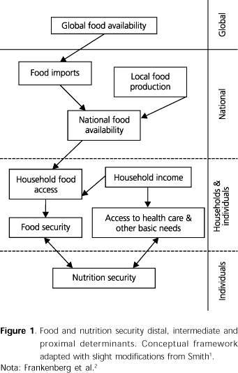

# Technology Stack

1. Python
2. R
3. Jupyter Notebook
4. RStudio
5. Tableau

# Food Export Restrictions and Supply Chain Disruptions

The biggest misconception everyone has is that empty grocery shelves are an indicator that there is a shortage of food. Whereas in reality, the export bans and various lockdown restrictions have led to disruptions in supply chains. Before elaborating on this further, let us understand what is supply chain management and why is it important.

## Supply Chain

A supply chain is a network between a company and its suppliers to produce and distribute a specific product to the final buyer.

Companies develop supply chains so they can reduce their costs and remain competitive in the business landscape.

➤ **Entities involved in a Supply Chain**

The entities involved in the supply chain include producers, vendors, warehouses, transportation companies, distribution centres, and retailers.

➤ **Functions of a Supply Chain**

The functions in a supply chain include product development, marketing, operations, distribution, finance, and customer service.

## Why is Supply Chain Management important?

Supply chain management is a very important part of the business process. There are many different links in this chain that require skill and expertise. When supply chain management is effective, it can lower a company's overall costs and boost profitability. If one link breaks down, it can affect the rest of the chain and can be costly.

## Supply Chain Management in Agriculture

An agriculture supply chain system comprises organizations/cooperatives that are responsible for the production and distribution of vegetable/Fruits/Cereals/Pulses or animal-based products.

There are two broad classifications of supply chain in agriculture.

  ➤ **Agriculture food supply chains for fresh agricultural products**

Products include fresh vegetables, flowers, fruits, etc.

These chains may comprise growers, auctions, wholesalers, importers and exporters, retailers and speciality shops and their input and service suppliers.

The main processes are the handling, conditioned storing, packing, transportation and especially trading of these goods.

 ➤ **Agriculture food supply chains for processed food products**

Products include portioned meats, snacks, juices, desserts, canned food products, etc.

In these chains, agricultural products are used as raw materials for producing consumer products with higher added value.

In most cases, conservation and conditioning processes extend the shelf-life of the products.

## Issues related to Supply Chain Management

In under-developed or developing countries such as India, despite agriculture being the biggest industry providing income to the majority of the population, the supply chain system is weak. This results in huge supply-demand gaps which leads to food insecurity among the masses, in addition to the farmers not getting adequate monetary returns for the crop production. The recent pandemic has pushed these inefficiencies to the limit and by the means of this project, we try to minimize these problems.

Here are some of the major issues regarding the food supply chain in India :

➤ Too many middlemen in the supply chain, leading to artificial price rise and huge differences between the price that farmers get and the final consumer pays.  
➤ Presence of asymmetric information i.e. many-a-times the middle man has more information than both farmers and consumers regarding prices, supplies and stocks available.  
➤ Transmissions related to price signals are weak leading to over and under production by farmers.  
➤ Lack of infrastructure and storage facilities like warehouses and cold chains, leading to post-harvest losses.  
➤ Skewed distribution of storage capacity between states.  
➤ Unavailability of insurance products to protect goods while on move. Underdeveloped ICT infrastructure and e-supply chains to transmit the right price signal

# Food Insecurity Experience Scale (FIES)

As discussed above, disruptions in food supply management systems lead to food insecurity among the population. The Food Insecurity Experience Scale or the FIES is a methodology to measure the severity of food insecurity as experienced by individuals or households in a way that is comparable across countries. The FIES is a new global standard for measuring food insecurity (access) that is valid, endorsed at the international level, and used for global and country monitoring.

The FIES Survey Module (FIES-SM) consists of eight questions regarding people's access to adequate food, and can be easily integrated into various types of population surveys. The questions are:

During the last 12 months, was there a time when, because of lack of money or other resources:

1. You were worried you would not have enough food to eat?

2. You were unable to eat healthy and nutritious food?

3. You ate only a few kinds of foods?

4. You had to skip a meal?

5. You ate less than you thought you should?

6. Your household ran out of food?

7. You were hungry but did not eat?

8. You went without eating for a whole day?

The eight questions, when analysed together, form a quantitative tool to measure the prevalence of food insecurity (at moderate and severe levels) in a given population using statistical methods.

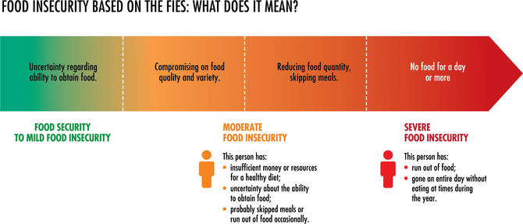

**Statistical methods**

**Item Response Theory and the Rasch model**

The approach used to analyse FIES data comes from Item Response Theory (IRT), a branch of statistics that permits the measurement of unobservable traits through analysis of responses to surveys and tests. As food security itself is an inherently unobservable characteristic, such as attitude or intelligence, it can be measured only by examining its observable manifestations. The specific IRT model applied to FIES data is the Rasch model, which is widely used in health, education and psychology.

The Rasch model provides a theoretical base and a set of statistical tools to 1) assess the suitability of a set of survey questions (“items”) for constructing a measurement scale and to 2) compare a scale’s performance across different populations and survey contexts.

# ANALYZING THE SUPPLY-DEMAND BALANCE OF COMMODITIES

When it comes to analyzing and predicting the supply demand balance of commodities a ratio called the Stocks to Use Ratio plays a very important role.

Stock-to-use ratios show the balance between supply and demand for a given commodity

Higher stock-to-use ratios mean more supply is available while lower ratios suggest a tighter supply situation

Stock-to-use ratios have significant market impact and should be considered when creating marketing plans

The mathematical formula for this relationship is as follows

SToU = (Beginning Stock + Total Production – Total Use)/Total Use

Can be simplified as

SToU = (Carry Over)/ (Total Use) * 100

Using the long hand formula, beginning stocks represent the previous year's ending or carryover inventories. Total production represents the total grain produced in a given year. Total usage is the sum of all the end uses in which the stock of grain has been consumed. This would include human consumption, export programs, seed, waste, dockage and feed consumption. By adding carry-over stocks to the total production, you will obtain the total supply. From the total supply, subtract the total use and the resultant figure will be the year ending carryover stock. The carryover stock divided by the total usage can be expressed as a ratio which when compared with previous years gives the market analyst an indication of the relative supply/demand balance for a particular commodity. This ratio can then be used to indicate whether current and projected stock levels are critical or plentiful. The ratio can also be used to indicate how many days of supply is available to the world marketplace under current usage patterns. (e.g. 20% stocks to use ratio for wheat indicates that there are 75 days’ supply of wheat in reserve)

To analyze this ratio, we have used a dataset provided by the USDA which has the information about Market Year, Worldwide Production, Supply, Demand, Imports, Exports, Area harvested, Domestic Consumption of various commodities, etc.

We have chosen the essential commodities namely – Corn, Rice and Wheat. By analyzing the stocks to use ratios of these commodities we have observed a somewhat linear pattern over the years.

We observed that in order to predict the ratio with more accuracy the data has to be analyzed country wise. Certain features such as the Ending, beginning stocks, Domestic Consumption, Imports, Exports show a strong correlation with the ratio. We fed these features to a model based on polynomial regression to predict the stocks to use ratio. The results are mentioned in a latter section.

## RESULTS -

The dashboards help us understand the trend in worldwide production and stocks to use ratios of various commodities over the years

### Stocks to Use ratio over the years

Here we have compared the ratios of 2020 with the year 2009(Financial Crisis) in order to study the impact of Economic Slowdown on Stocks.

Stocks with and without china tell us that in terms of broad commodity groups, china’s role in international commodity trade only matters to the extent that it affects the relative distribution of supply and demand of different commodities across countries. For example, China’s strategic policy decision to strive for self-sufficiency in key grains but rely on imports of oilseeds has likely had major implications for global agricultural trade patterns.

The SToUs with and Without china to understand the impact of china on Global Agri trade.

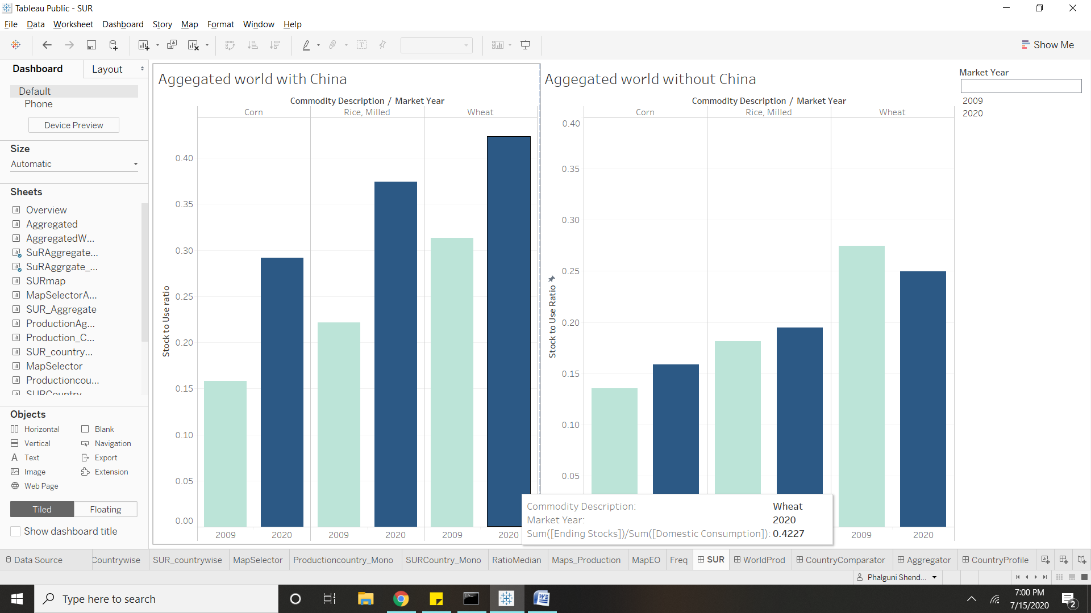

Trend in Production and Stocks to use ratio over the years

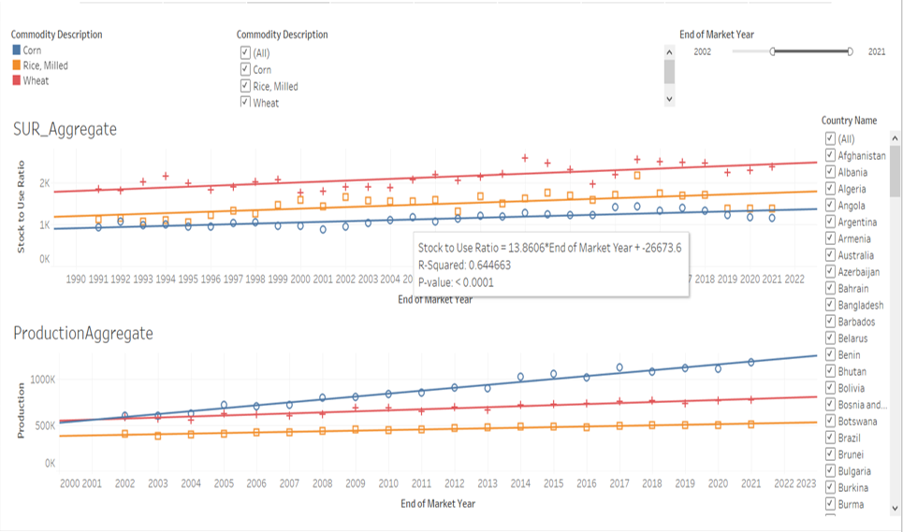

Analyze the SUR of a particular country using maps

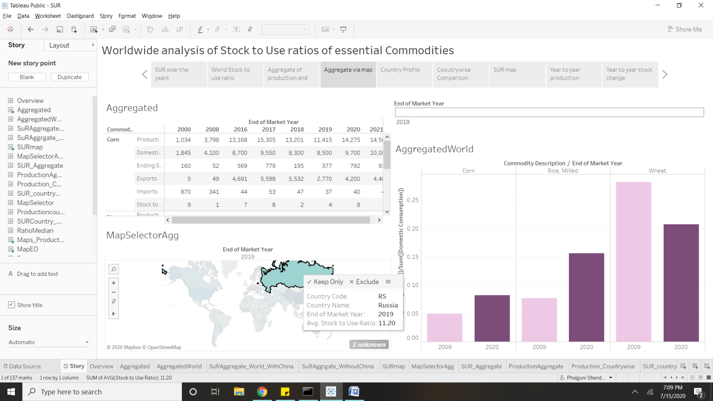

Country specific trend in production and SUR of all 3 commodities over the years

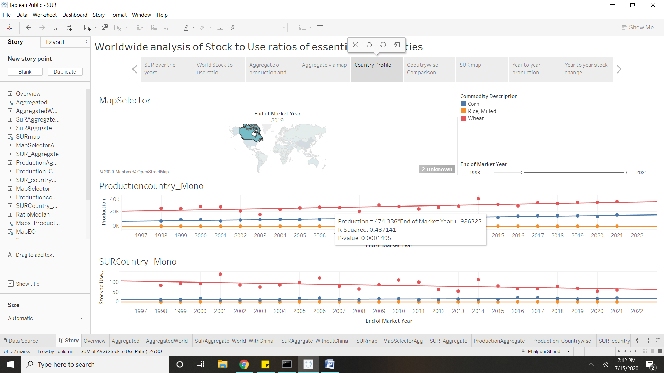

SURs of all 3 commodities in the specified years. (Comparison with 2009 crash)

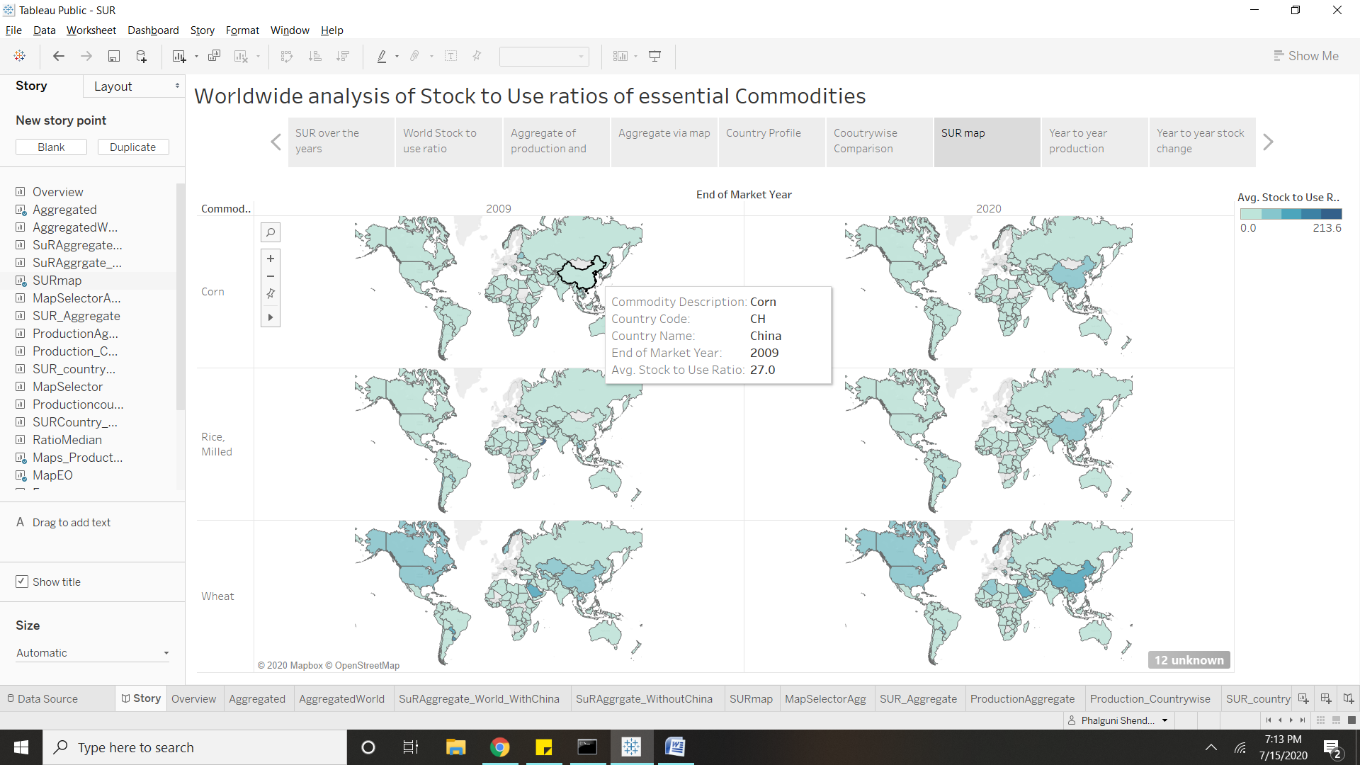Dashboard link : [https://public.tableau.com/profile/phalguni.shendye#!/vizhome/SUR_15942289520880/Story](https://public.tableau.com/profile/phalguni.shendye)

## Results –

### Model to predict the supply-demand gap using the Stocks to Use Ratio

We observed that in order to predict the ratio with more accuracy the data has to be analyzed country wise. The reason being the factors affecting the ratio vary depending on the country as the percentage of imports, exports are different as well. Certain features such as the Ending, Beginning stocks, Domestic Consumption, Imports, Exports are highly correlated with the ratio. We fed these features to a model based on polynomial regression of degree 2, to predict the stocks to use ratio. As the features are of various scales and magnitudes, we applied feature normalization using MinMax scaling on the selected features. When analysed the 30-year data of 3 commodities of India, we got a R – squared score (Training) = 0.931 and – squared score (Testing) = 0.972

# FIES Analysis Methodology:

## Key concepts

**Latent trait and continuum of severity**

Food insecurity exists along an underlying **continuum of severity**, and the FIES is intended to reveal information across a range of food insecurity experiences.

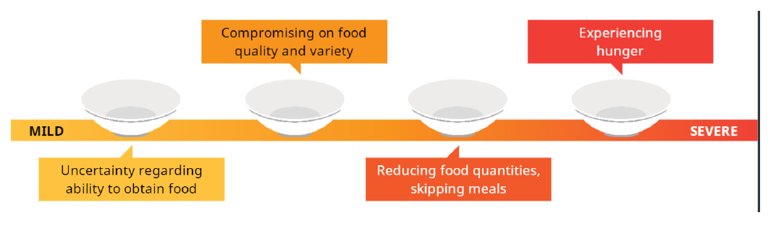

What is **challenging** is that food insecurity is an unobservable, or **latent trait**, which means that it **cannot be measured directly**, as is possible with variables such as height and weight. One must instead learn about food insecurity by studying its **observable manifestations**.

**Severity of respondent and question**

There are **two key concepts** underlying the approach to FIES measurement:

 People answer the questions according to the severity of the food insecurity they **experience**.

 The **questions** and the **respondents** (individuals or households) are located on the **same underlying continuum** of severity of food insecurity.

***Example:***

*An example that may help one understand comes from* ***educational testing****.*

*Imagine a* ***hypothetical scale of proficiency*** *in an academic subject such as mathematics.*

***Students*** *can be distributed along a continuum of mathematical proficiency,* ***from lowest to highest skill level****, depending on their answers to exam questions.*

***Exam questions*** *can also be located on the same scale, as they* ***represent different levels of proficiency****, depending on their difficulty.*

## Relative severity of questions

A **fundamental feature** of the FIES is that the **order** of the **questions** along the scale **cannot be considered fixed** across countries. In different countries, or even sub-populations, the relative severity associated with each of the eight FIES questions may vary. There are two main reasons for this:

 food insecurity conditions are **experienced or managed differently** in different cultures and livelihood systems

 **nuances in translation** mean that the same question is interpreted in different ways in different contexts

|  |
| --- |
| ***Example***  *In some cultures where mild food insecurity is commonplace,* ***worrying*** *about having adequate food may not be the first or most common experience people have when facing food insecurity. In such a case, people may make dietary changes more quickly, and worry only when their food insecurity situation becomes more severe.*  The **severity** of the FIES item referring to worry would therefore **be higher** in this context*.* Standard labels for the eight questions Because the order of the eight questions is not constant, for the purpose of analysis, the FIES methodology uses **standard labels** for each of the questions rather than numbering them.  *“Now I would like to ask you some questions about food. During the last 12 months, was there a time when…”* |

…you were **worried** you would not have enough food to eat because of a lack of money or other resources? ***WORRIED***

…you **ate less** than you thought you should because of a lack of money or other resources? ***ATELESS***

…. you were unable to eat **healthy** and nutritious food because of a lack of money or other resources? ***HEALTHY***

…your household **ran out** of food because of a lack of money or other resources? ***RANOUT***

…. you ate only a **few kinds** of foods because of a lack of money or other resources? ***FEWFOOD***

…you were **hungry** but did not eat because there was not enough money or other resources for food? ***HUNGRY***

…you had to **skip a meal** because there was not enough money or other resources to get food? ***SKIPPED***

…you went without eating for a **whole day** because of a lack of money or other resources? ***WHLDAY***

***Important terminology***

*For the purpose of FIES analysis, the term* ***item*** *will refer to the* ***questions*** *in the survey module.*

*A* ***respondent*** *is an individual or household responding to the items.*

*A* ***case*** *is the unit for which data are collected and appear in a dataset.*

*A* ***parameter*** *is a* ***numerical quantity*** *that* ***characterizes*** *a given population or some* ***aspect of it****, and that can be* ***estimated*** *using observed* ***data****.*

In the case of the FIES, **parameters** express the severity of food insecurity of both:

* the FIES questions (**item parameters**);
* the people who answer them (**respondent parameters**).

## Preparing the data for analysis

To prepare the data collected through the FIES survey module for analysis, **each item should be coded**, so that: **0** is used for a "**no**" response; **1** is used for a "**yes**" response.

This is an example of FIES data along with the standard labels for the eight items.

***Example:***

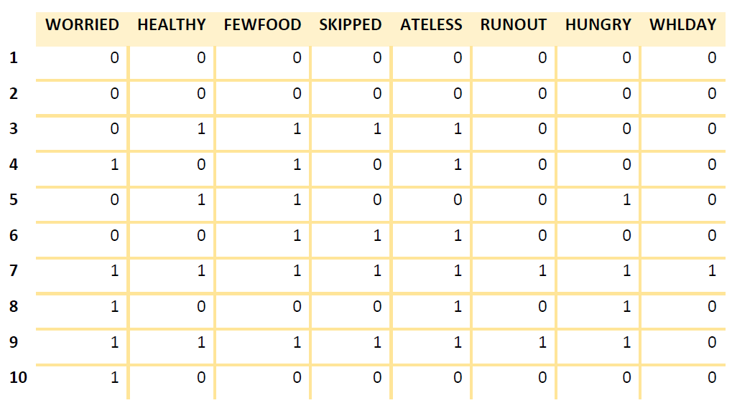

## 

## FIES analysis methodology

**Item Response Theory** (IRT) is a methodology used to analyse responses to survey or test questions.

The **Rasch model** is one of several models in IRT and is applied for the analysis of FIES data. Item response theory aims to improve the measurement accuracy and reliability of surveys and tests through analysis of response data. The item response theory (IRT) measurement model known as the Rasch model provides a theoretical base and a set of statistical tools to:

* assess the suitability of a set of survey items for scale construction
* create a scale from the items, and compare performance of a scale in various populations and survey contexts.

### Assumptions of the Rasch model

The Rasch model is based upon **four key assumptions**:

1. Only one dimension is represented by the response data. For the **FIES**, this is the **access** dimension of **food security**.
2. An individual’s responses to the eight FIES items are **correlated** with each other only because they are all conditioned by the **severity** of food insecurity of that **individual**.
3. The **greater the severity** of food insecurity experienced by a respondent, the **higher the likelihood** that he or she will **respond affirmatively** to each item.
4. All items are **equally strongly related** to the **latent trait** of food insecurity and **differ only in severity.**

## Expected response pattern

The logic behind the Rasch model is that the **likelihood of a respondent reporting an experience** depends on the distance along the scale between the severity of that respondent and that of the item associated with that experience.

This means that once the **order of severity** of the eight **questions has been established**, specific **patterns of responses** by individual respondents can be considered more or less to "**fit**" the logic of the model.

## The analytical tools

Voices of the Hungry project provides the following **free analytical tool** to facilitate the **Rasch analysis of FIES data**, although other statistical software can also be used to carry out the analysis.

**RM.weights -** This package is aimed at food security measurement specialists and those familiar with the R open source statistical software. The "R Manual for the Implementation of Voices of the Hungry Methods to Estimate Food Insecurity" provides instructions for its use. It requires users to download the R open source software on their computer and use R programming language. For the RM.weights package, data can be of any format and columns can have any label.

## How the tool works?

Estimating the item parameters:

The **item parameter** is estimated based on the overall **pattern of responses** given by all respondents. A question representing a **less severe** experience will have a **smaller parameter** value, whereas a question representing a **more severe** experience will have a **larger parameter** value.

The **relative severity** of the items is determined based upon the understanding that the **more severe** an item is, the **less likely** respondents are to **report it**.

Difference between the raw score and the respondent parameter

The **raw score** is the **number** of affirmative responses given to the eight FIES questions - it is an **integer number** with a value between zero and 8.

Even if expressed by **numbers**, the raw score only provides an **ordinal measure** of food insecurity: the difference in severity between **adjacent raw scores** is **not constant**.

**Raw score**

Looking at raw scores only, you can see that a respondent with a raw score of 6 is more food **secure** than someone with score of 7 and more food **insecure** than someone with score of 5.

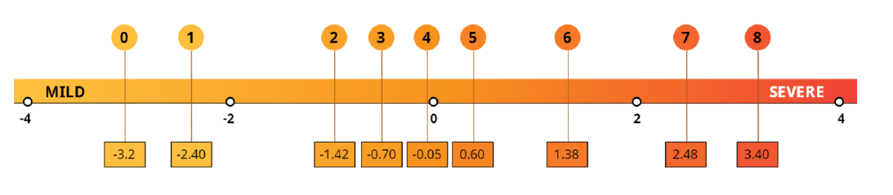

**Respondent parameter**

Using respondent parameters, however, you see that difference in severity is smaller between raw scores 5 and 6 than between 6 and 7.

**Statistical validation** allows us to see if the data are **consistent with assumptions** of the Rasch model. If they are, we can say that:

- the **raw score** is an **ordinal measure** of the severity of food insecurity

- the **respondent parameter** is an **interval-level measure** of severity

**Respondent parameters** allow us to **more precisely** evaluate the relative differences in food insecurity severity along the scale, between the respondents with each raw score.

***Important terminology:***

***Ordinal Scale:*** *In an* ***ordinal measure****, the order of values is meaningful, such as low, medium and high, but the exact distance between these values is unknown.*

***Interval Scale:*** *In an* ***interval measure****, the order of and distance between the values are known and meaningful.*

**FIES analysis methodology**

S**tatistical validation** is an analysis that is used to check the quality of the data collected. This involves **applying** the Rasch Model to the FIES response data and **assessing** whether the data conform to the **model’s assumptions**. If the data do conform to the assumptions, we can conclude that the **data can be used** to calculate a valid measure of food insecurity.

## Assessing data quality

The next step is to learn **how to carry out statistical validation**, which will help you to:

* Determine **how well** the **FIES works** in the population where it was administered
* Identify **problematic items** where greater attention to translation and/or survey administration may be required
* Identify **outliers**, or respondents with highly **unexpected** response patterns
* Determine whether the FIES does **perform differently** when administered to different language groups or culturally distinct subpopulations

## Interpreting Rasch output

The Rasch model allows us to produce **four results** that are **useful to test the quality of data** collected. They will help you to identify:

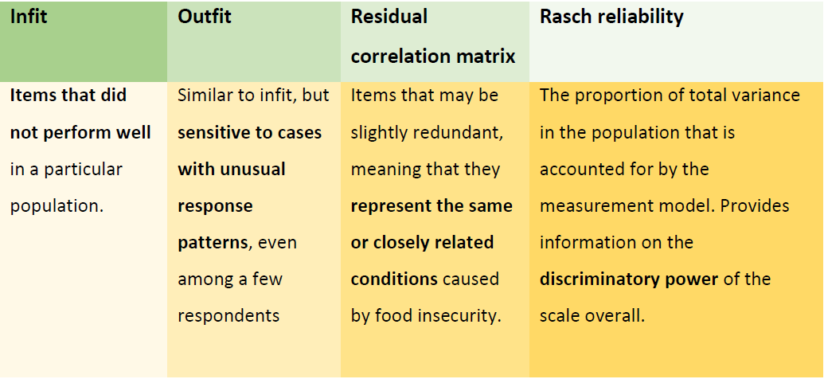

**Infit:**

**LOW (Below 0.7)**

A **single item** with a particularly **low infit** may be somewhat redundant with other items.

**0.7 – 1.3**

An **adequate fit** to the Rasch model is indicated by **infit and outfit statistics of 0.7 – 1.3** for each item.

**HIGH (Above 1.3)**

These are items with unexpected response patterns.

**Outfit**

An outfit of **>2** is considered **"high"**

**Residual correlation matrix**

A residual correlation between a **pair of items** is **considered high if it is >|0.4|**

**Rasch reliability**

Rasch reliability provides information about the **discriminatory power of the overall scale**, measuring the proportion of variability in the data that is explained by the Rasch model.

* For an 8-item FIES scale, a Rasch reliability value **above 0.7** is considered acceptable.
* For a 7-item scale, a Rasch reliability value **above 0.6** is considered acceptable.

The response to each **single item** as a measure of the latent trait has a **substantial measurement error**. But taken **together**, every item:

* **contributes information** to measuring food insecurity along the severity continuum;
* increases **precision**;
* **reduces** the overall impact of measurement **error**;
* **filters** out **any subjective** component that a single item may have.

## The two FIES-based indicators

FAO produces **two FIES-based indicators** for global monitoring: FImod+sev and FIsev. The **first of these** has been selected as a **monitoring Indicator for SDG Goal 2, Target 2.1**. Both are expressed in terms of the prevalence of food insecurity in the population, and they **differ only** in the **level of severity** at which prevalence rates are assessed. These indicators are:

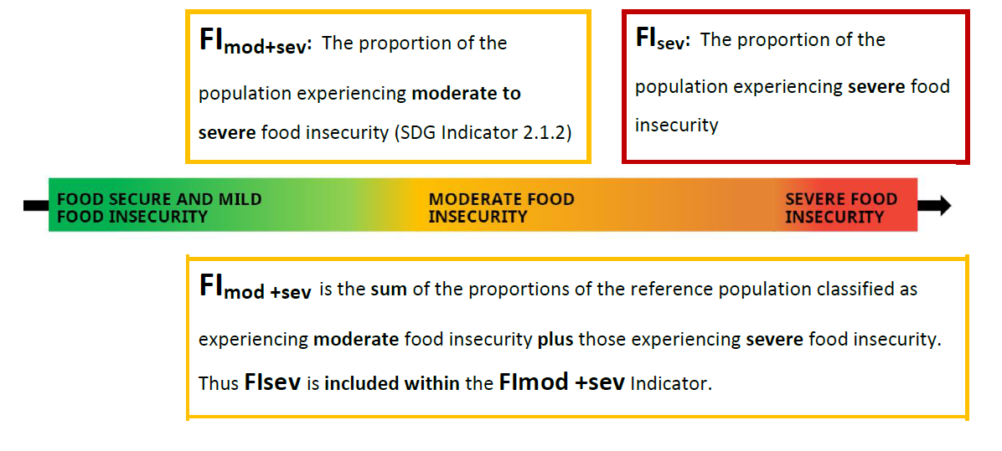

**Equating: calibrating to a common metric**

Application of the Rasch model on a single country dataset produces a scale that is, to some extent, arbitrary and **idiosyncratic** to that country. Before comparing measures obtained in two different countries or populations, it will be necessary to **calibrate the two scales on a common metric** by **equating the mean** and the **standard deviation** of the set of items that are common to the two scales.

## The FIES global standard scale

The global standard is a set of item severity values that has been created based on results from over 140 countries covered by the Gallup World Poll in 2014, 2015 and 2016.

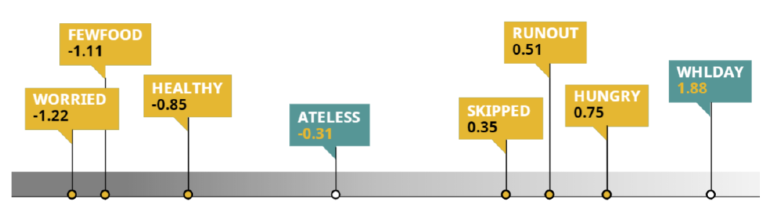

**The Gallup World Poll**

In 2014, 2015 and 2016, the FIES was included in the Gallup World Poll (GWP) in nearly 150 countries. This allowed FAO to develop a **sound analytic methodology** and a **global standard** for producing estimates of food insecurity that are valid, reliable and comparable across contexts.

The GWP database has been used to define **provisional baseline estimates** of the prevalence of moderate or severe food insecurity. These estimates will serve as a starting point for measuring progress towards the Sustainable Development Goals (SDGs).

## Determining common and unique items

The important step in equating is to **determine which items** are **common between two scales**. The two sets of item parameters can only be compared once **one of the two scales' item parameters** (the mean and standard deviation) have been **standardized to those of the other**.

By doing this one can then **identify unique items** whose **parameters differ too much** between the two scales. The equating procedure can then be repeated, omitting the unique items.

## Calculating prevalence estimates

The final step is to calculate the overall prevalence of food security in the population.

This is done using the **weighted proportion** of **cases** in the population **with each raw score** to generate a **weighted sum** of the **raw score-specific probabilities**.

**The following *respondent-level* data elements are computed from the FIES module:**

- **“Raw score”:** is the sum of affirmative answers given by respondents to each of the FIES questions. There are nine possible raw scores, integers ranging from 0 to 8

- **“Raw_score_par”** and **“Raw_score_par_error”:** the raw score (associated to each respondent) parameter provides information on the severity of a respondent’s food insecurity, given the number of FIES questions they have affirmed. These variables include the respondent severity parameter and the corresponding error, both expressed in the metric of the FIES global reference scale, and thus are comparable across countries, and directly comparable with the global thresholds used for classification into classes of food insecurity severity (approximately -0.31 for moderate or severe food insecurity, and 1.88 for severe food insecurity). Raw score parameters are a *linearized*, *interval-level* transformation of the raw score. They can be used in analyses that require interval-level measurement. Within a country, raw score parameters are the same for all cases that reported the same raw score but this is not true across countries due to differences in equating each country’s measures to the global standard.

They are obtained as the conditional maximum likelihood estimates of the “person parameters” under the assumptions of the Rasch measurement model. As the conditional maximum likelihood estimation approach does not allow for estimation of parameters and errors for raw scores 0 and 8, a special treatment is necessary for these cases. FAO has developed a dedicated protocol to associate a measure of parameter and error to raw score 8.

- **“Prob_Mod_Sev”**: this is the individual probability of belonging to the class of “moderate or severe food insecurity” (ranging from 0 to near 1), or in other words, being at least moderately food insecure. As for the raw score parameters, within a country they are the same for all respondents reporting the same raw score. As a food insecurity measure, the probabilities take into account data measurement error and recognize that reporting a given raw score is not sufficient to associate an exact measure of food insecurity severity to the respondent, so that there may be a whole range of severities associated with a given raw score. It can be thought of as the proportion of people in the population represented by the sampled person whose true food insecurity severity exceeds the threshold that defines moderate food insecurity. Such a threshold is set at the severity level of the item, “In the past 12 months did you eat less than you thought you should....” on the FIES global standard scale. The value is based on adjustment of respondent severity parameters to the FIES global standard, so is intended to be comparable across countries. The probability of moderate or severe food insecurity for cases with raw score zero will be presented as zero. Values for raw score 8 will be based on FIES standard methods used to calculate national prevalence rates. This data element will be missing for cases with missing responses to any of the FIES questions.

- **“Prob_sev”**: this is the individual probability of severe food insecurity (0 to near 1). It is similar to the probability of moderate or severe food insecurity except that the threshold is more severe, i.e. at the severity level of “In the past 12 months did you go a whole day without eating....” on the FIES global reference scale.

## Prevalence of food insecurity in the adult population:

The weighted mean of the variables “Prob_Mod_Sev” and “Prob_sev” using the post-stratification sampling weights (variable “wt” in the data) is used to calculate the country-level prevalence rate of moderate or severe food insecurity, and severe food insecurity only, in the adult population for each country.

The formulas to obtain the two indicators are reported below:

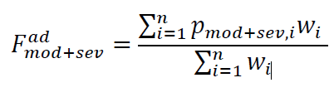

at moderate or severe level, and

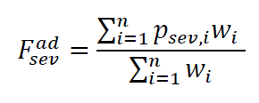

level, where 𝑝𝑚𝑜𝑑+𝑠𝑒𝑣,𝑖 and 𝑝𝑠𝑒𝑣,𝑖 are variables “Prob_Mod_Sev” and “Prob_sev” for individual *i* in the sample, 𝑤𝑖 is the variable “wt” for individual *i* in the sample and *n* is the sample size for a given country and a given year.

***Note:*** *Although the* RM.weights *library provides us with methods producing values which may differ in notations, it uses the same parameters mentioned above to calculate the prevalence rates.*

## Results:

Prevalence of undernourishment

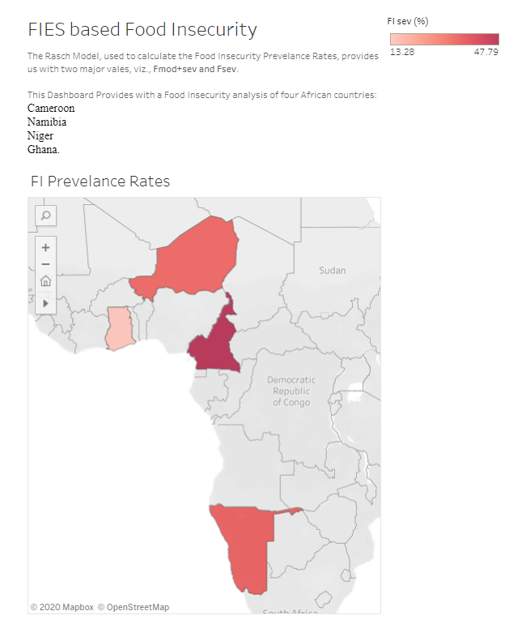

Number of food insecure cases by gender

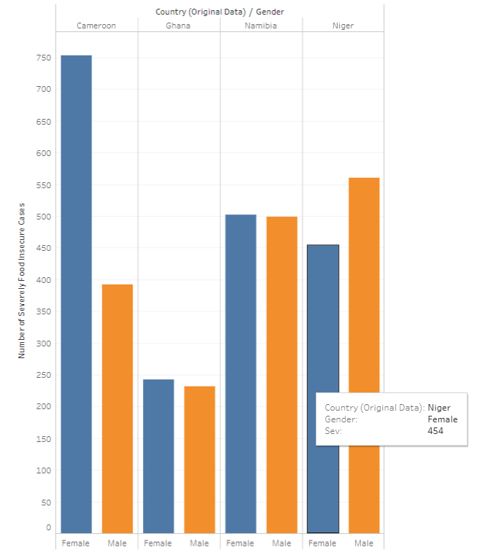

Number of food insecure cases by age

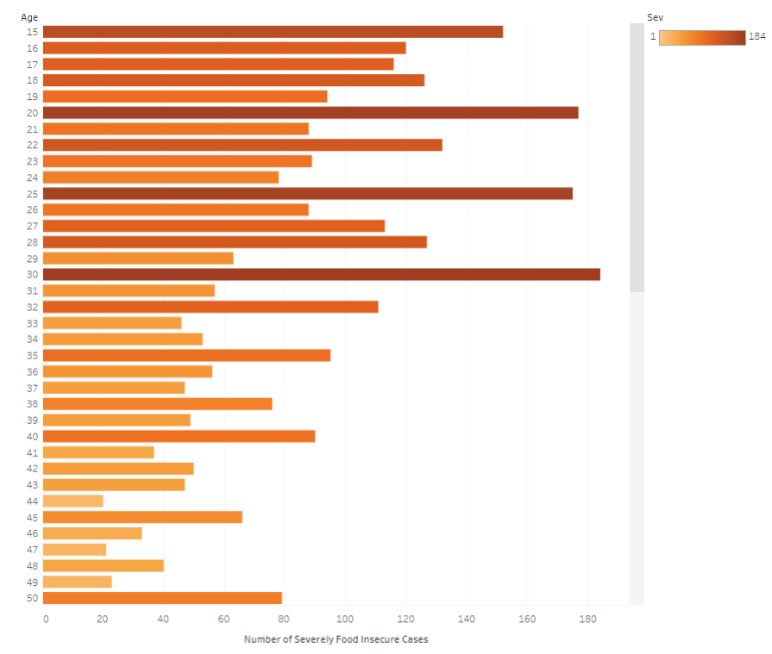

Number of food insecure cases in rural or urban areas

Rural - Green, Urban - Brown

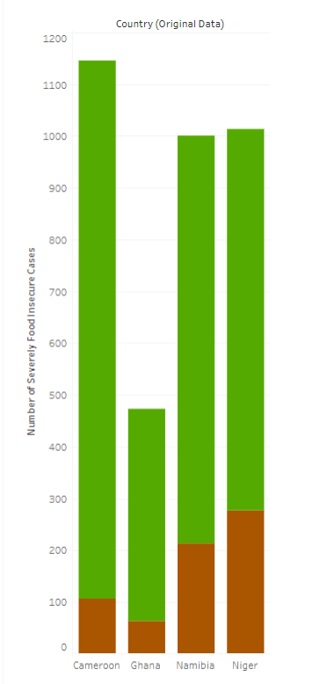

Dashboard link: [**https://public.tableau.com/profile/ashutosh.pandey3014#!/vizhome/RaschModel/FoodInsecurity?publish=yes**](https://public.tableau.com/profile/ashutosh.pandey3014)

# CONCLUSION:

As the COVID-19 pandemic rages on, the entire world has been reeling under its effects. The pandemic’s socio-economic impacts have resulted in the loss of jobs of millions of people worldwide. The extended lockdowns mean families have no income, which in turn has jeopardized their food security. The largest sector hit by this has been the one consisting of migrants, daily wage workers, and families below the poverty line who require daily income in order to obtain basic amounts of food and nutrition. These people have to be provided with funds, through which they can buy essential commodities and be properly nourished. This project will help governments to understand what must be done to ensure food security among its masses, especially the population below the poverty line, by visualizing charts and graphs.